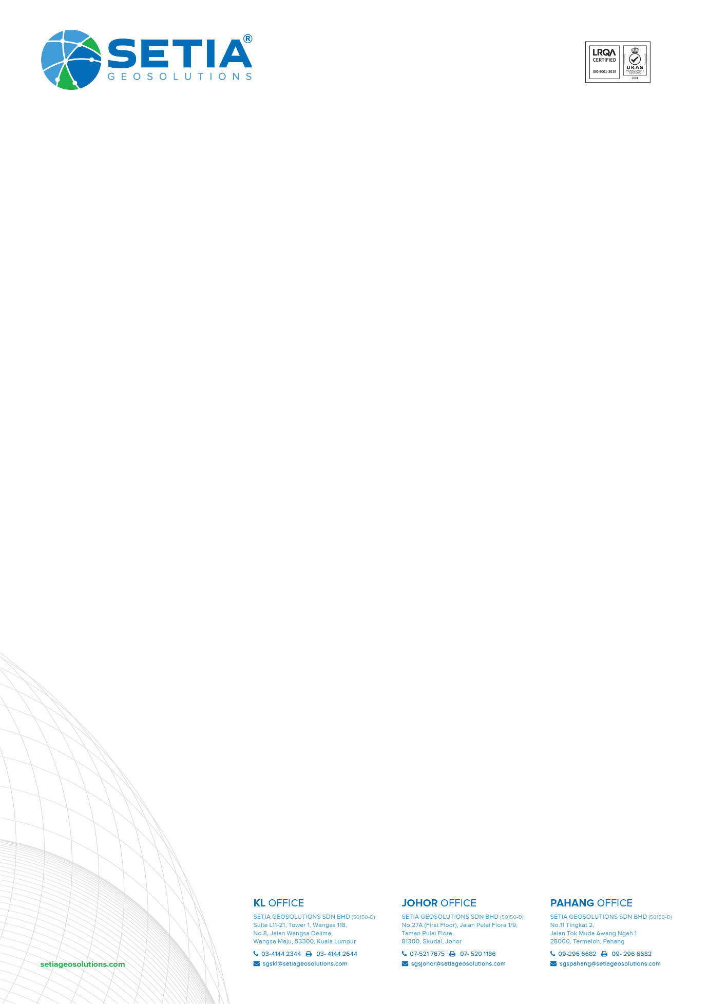**Our Ref.: SGS(J).23Q006**

**Your Ref.: -**

**Date: 02th February 2023**

**BY HARDCOPY**

**Managing Director,**

Southkey City Sdn Bhd**,**

No. 3, Persiaran Southkey 1, Southkey,

80150 Johor Bahru, Johor Darul Takzim.

Dear All.

**RFQ FOR DETAIL AND TOPO SURVEY ON LOT PTD 208571 (PRECINT 4), MUKIM PLENTONG, JOHOR BAHRU, JOHOR.**

First and foremost, we would like to thank you for inviting us to quote for the above work. Submission shall be including as per item below:

1. To undertake Topographic Survey approximately 3 hectares as per attached information by you.
2. The duration required to complete shall be in three (3) weeks including deliverables upon field commencement.
3. Provision of four (4) sets of plans in A1 size at appropriate scale and one (1) set of softcopy in AutoCAD and PDF format upon completion of the survey.
4. Our fee to carry out the survey as per attached in BQ document.
5. Mode of payment - 100% upon invoice received.
6. This quotation validity period is about 90 days after submission date.

Should you seek further clarification, please do not hesitate to contact us.

Thank you.

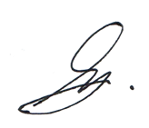**SETIA GEOSOLUTIONS SDN BHD**

……………………………………..

SYAIFUL AMRI BIN AHMAD TARMIZI

*Business Development Executive*